

Interdisciplinary Research: Appointment, Promotion, and Tenure (APT) Toolkit

*APT Toolkit to recognize, support, and reward interdisciplinary research and collaboration at the University of Washington*

Brenda Zierler, PhD, RN, FAAN Jonathan D. Posner, PhD

Nicole Summerside, MHA



# gold boundless barTABLE OF CONTENTS

PREFACE . . . . . . . . . . . . 2

DEFINITIONS . . . . . . . . . . . 4

APT CRITERIA LANGUAGE . . . . . . . . . 4

RESOURCES AND EXAMPLES FOR FACULTY . . . . . . . 7

Section 1: Faculty Candidate 7

**Item a:** Goal or Self Advocacy Statement 8

Item b: Curriculum Vitae 8

Section 2: Promotion Letters 11

Item c: Review of Potential Letters 11

Item d: Letter to External Reviewer 12

Section 3: Institutional Structures & Policies 14

**Item e:** Indirect Cost Recovery and UW Office of Research Resources 14

**Item f:** Scholarly Identity and Digital Portfolios 16

ACKNOWLEDGEMENTS 17

REFERENCES 17



# Preface

gold boundless bar

## Acronyms

|  |  |
| --- | --- |
| APT | Appointment, Promotion, and Tenure |
| CTSA | Clinical and Translational Science Award |
| ITHS | Institute for Translational Health Science |
| IR | Interdisciplinary Research |
| UW | University of Washington |
| WWAMI | Washington, Wyoming, Alaska, Montana, and Idaho |

## Background and Executive Summary

“Interdisciplinary thinking is rapidly becoming an integral feature of research as a result of four powerful drivers: the inherent complexity of nature and society, the desire to explore problems and questions that are not confined to a single discipline, the need to solve societal problems, and the power of new technologies.” (National Academies of Science, 2015, p. 41)

In 2017, the (UW Institute of Translational Health Sciences (ITHS) received a 5-year Clinical and Translational Science Award (CTSA) from the National Institutes of Health to support translational research in the Washington, Wyoming, Alaska, Montana, and Idaho (WWAMI) region. A new component of the grant for all CTSA programs was to carry out Team Science education and training to support team science or interdisciplinary research (IR). This work has been co-led by Brenda Zierler (Nursing), Jonathan Posner (Engineering), Erin Blakeney (Nursing), and Nicole Summerside (Health Administration). An ongoing area of work for the ITHS Team Science initiative is to promote the recognition and reward of IR in promotion and tenure processes at UW. There is currently a lack of well-defined criteria and associated metrics for documenting team science contributions when compared to the well-established criteria and achievement metrics for independent research contributions (e.g., PI role on grants, first or senior author, number of externally funded grants as PI, etc.).

In 2018, UW faculty published the Faculty 2050 Report that outlines a shared vision for the increasing opportunities for faculty to contribute to activities that promote the public good, to develop strategic plans to support diversity, equity, and inclusion, and the pursuit of scholarly excellence in research and training. There were a series of cross-cutting recommendations, including an immediate request for unit leaders to identify and share how tenure and promotion guidelines address expanded forms of research and training, including collaborative, community engagement, and interdisciplinary. This report also recommends, as a next step, that UW identify central funding for interdisciplinary, collaborative, and/or community-engaged scholarship as well as establish university-wide resources for strengthening support of collaborative, community-engaged, and interdisciplinary scholarship.

To better understand the current landscape and support for IR at UW, we administered a survey to faculty across the six Health Sciences Schools and the College of Engineering in 2018. The purpose of the survey was to assess attitudes, perceptions, and current structures for APT within the context of IR within their schools and colleges. Survey results showed that the majority of respondents indicated that IR is valued, and a high percentage of faculty are currently conducting IR (95%); however, faculty noted the lack of policies and infrastructure at the university level to support and reward faculty to engage in IR. Also noted was a lack of awareness by APT committees on what constitutes, and how to evaluate IR, since APT criteria mostly focus on individual accomplishments and not on individual contributions within a team conducting IR.

Over the past five years, we have organized workshops with APT committee members and champions across the six UW Health Sciences schools and the College of Engineering to gather recommendations and support for IR in the context of APT. We identified the need for guidelines and tools for documenting team science contributions to help individual researchers, chairs, deans, and APT committees evaluate team science-focused researcher’s contributions to IR. These efforts have led to the development of this Toolkit. The APT Toolkit is designed to aid candidates, chairs, and APT committees in recognizing IR (or team science) during appointment and promotion processes. The Toolkit provides standardized language and definitions of IR for schools and colleges to incorporate into their APT criteria.

With our APT Champions from the six UW Health Science Schools and College of Engineering, we hope to do the following: provide guidance and associated metrics describing team science achievements and impact in the context of APT and policies; provide examples of how faculty participating in team science achieve success; establish metrics for assessment and examples of indicators of the impact of team science; and, highlight institutional support for the recognition of team science and removal of obstacles to valuing IR. We hope to ensure that all departments, schools, and colleges intentionally educate APT Committees and onboard new faculty with the goal of introducing policies and rubrics related to IR and scholarship.

Our goal is to disseminate this APT Toolkit broadly and provide biannual workshops to support early-career faculty interested in becoming team science researchers. The APT Toolkit is a living document that will be updated as we gather more information, feedback, and examples of successful promotion and tenure of team science-focused researchers. We will collaborate with APT leads across the UW to co-create guidelines for documenting team science achievements in order to decrease subjectivity and bias in APT reviews. In addition to collaborating with APT faculty leads in the six health science schools and the Collect of Engineering, we are collaborating with other UW campus groups and initiatives (e.g., Community-Engaged Scholarship, Population Health) who are increasing awareness and recognition of scholarly work conducted with teams,

communities, community organizations, or community leaders. This work supported a [Class C Resolution](https://uw-s3-cdn.s3.us-west-2.amazonaws.com/wp-content/uploads/sites/71/2022/03/11163624/615.pdf) approved at the university level on community-engaged scholarship that includes language supporting interdisciplinary research and links to our APT Toolkit.

If you are interested in learning more about the APT Toolkit please reach out through our contact information below.

|  |  |
| --- | --- |
| Brenda Zierler, PhD, RN, FAAN  UW School of Nursing  [brendaz@uw.edu](mailto:brendaz@uw.edu) | Jonathan Posner, PhD  UW College of Engineering [jposner@uw.edu](mailto:jposner@uw.edu) |
|  |  |

# Definitions

gold boundless bar

Interdisciplinary research is a mode of research by teams or individuals that integrates information, data, techniques, tools, perspectives, concepts, and or theories from two or more disciplines or bodies of specialized knowledge to advance fundamental understanding or to solve problems whose solutions are beyond the scope of a single discipline or area of research practice.

National Academy Press, 2005, p.2

Within the context of research, “Team Science” has been defined as a collaborative effort to address a scientific challenge that leverages the strengths and expertise of professionals trained in different fields.

National Research Council. 2015. Enhancing the Effectiveness of Team Science. Washington, DC: The National Academies Press. https://doi.org/10.17226/19007.

# APT Criteria Language

gold boundless bar

In 1999, the UW Faculty Senate passed Class A Legislation No. 99 which included specific language supporting interdisciplinary research in promotion and tenure (24.32.B).

*Other important elements of scholarly achievement include involvement in and contributions to interdisciplinary research and training.*

This language opens the door to recognizing and rewarding faculty who pursue IR; however, there are few examples of individual schools, colleges, and departments who have translated this language to specific criteria and metrics in their own promotion and tenure guidelines. With the goal of promoting and rewarding IR across campus, we recommend that each academic unit (school, college, or department) include some language in their promotion and tenure guidelines that supports the content of their specific discipline.

**Interdisciplinary Research Suggested Language for APT Criteria**

Here we provide a general paragraph that defines IR and could be included in promotion and tenure guidelines with the goal of recognizing and rewarding IR during promotion processes.

*UW aims to promote and recognize interdisciplinary research (IR). The National Academies defines IR as, “a mode of research by teams or individuals that integrates information, data, techniques, tools, perspectives, concepts, and or theories from two or more disciplines or bodies of specialized knowledge to advance fundamental understanding or to solve problems whose solutions are beyond the scope of a single discipline or area of research practice.” The UW recognizes original research contributions in peer-reviewed publications as well as integrative and applied forms of scholarship that involve cross-cutting collaborations with business and community partners, including translational research, commercialization activities, and patents.*

*IR often requires significantly more faculty time and effort. The evaluation of a candidate’s*

*research productivity will, therefore, encompass not only an individual’s contribution to research but also assess the extent to which the individual worked beyond the bounds of a specific discipline and engaged in collaboration and cross-disciplinary activities.*

## Examples of Language Implemented in Promotion and Tenure Guidelines

Below we provide some examples of promotion and tenure guideline language used at UW and Case Western University

**UW School of Public Health** – September 2014

*“Members of the faculty at the University of Washington in the School of Public Health (SPH) are scholars in their respective disciplines in public health. Members of the faculty are encouraged to collaborate with fellow faculty or students whenever it is appropriate and conduct themselves in a collegial manner. Interdisciplinary contributions are encouraged.”*

*“Innovative and interdisciplinary efforts in teaching, research, and academic Public Health Practice scholarship are encouraged and will be given special recognition in the promotion review.”*

**UW Department of Global Health** – May 2009

*“Interdisciplinary research: DGH aims to promote interdisciplinary global health interests throughout the UW. Interdisciplinary research can often require greater faculty time and effort; the evaluation of candidate’s research productivity will therefore encompass not only an individual’s contribution to research but also assess the extent to which the individual worked beyond the bounds of a specific discipline and engaged in collaboration and cross-disciplinary activity.”*

*“DGH recognizes and assigns value to a wide range of teaching activities because of the inter-disciplinary nature of global health and its mission to build human and institutional capacity in resource-limited settings through education and related capacity-building activities. The critical role of interdisciplinary global health education and training within and beyond the health sciences frequently requires greater faculty time and effort than is usually necessary for the development and delivery of the more narrowly focused didactic and experiential education in many other fields. DGH appointment and promotion criteria must, therefore, emphasize the value of these interdisciplinary activities and reward them.”*

**UW School of Medicine** – February 2020

*“Independence: changing paradigms of interdisciplinary work and “team science” can often make attribution of effort and the assignment of an individual’s contribution to scholarship and a research program difficult. Independence in research is a hallmark of a member of the regular faculty and some research faculty. Yet defining it by classic roles and responsibilities, such as senior authorship or PI status on a grant, may be difficult. This is especially true of faculty on the research track where team science and programmatic needs may limit time and resources for independent scholarship. Clear enunciation of the candidate’s contribution and impact on a scientific program is essential. This should be described in the self-assessment, the chair’s letter, and in internal referee letters.”*

**UW School of Nursing** – May 2020

*“Scholarship and research effectiveness encompass multiple paradigms and methodologies. Systematic inquiry includes empirical research inquiry, clinical practice inquiry, historical and policy analyses, and systematic and synthetic reviews of knowledge. Scholarship, as described in the Faculty Code and Governance (Section 24-32) is reflected in contribution to knowledge, performance of students related to inquiry, constructive professional contributions, quality of scholarly products, impact of work, funding, and interdisciplinary research.”*

*For Assistant/Associate Professors*

*Participates on nursing research teams in focused area of scholarship.*

*For Associate Professors*

*Participates in interdisciplinary research teams in focused area of scholarship.*

*For Full Professors*

Leads interdisciplinary research teams in focused area of scholarship.

**Case Western School of Medicine** – February 2019

*“Typical team scientists are those for whom the greater portion of their research accomplishments, publications, and national reputation rest on original, creative, indispensable, and unique contributions made either a) in conjunction with a group of other scientists or b) with a changing series of groups of other scientists. A team scientist may play the same or different roles within each team. A successful team scientist will be able to document national recognition for the research area, approach, technique, or theme that characterizes his or her work through such means as study section memberships, invited presentations, editorial positions on boards of peer review journals, national awards for such work, etc.*

1. *Team candidates’ personal statements should include a detailed description of the type or types of contributions they have made to the team or teams of which they are a part and describe the type of team scientist they believe themselves to be;*
2. *Team candidates should annotate each team publication and team grant on their CV to indicate the precise role and the nature and extent of the contribution they made to that publication or research;*
3. *At least two of the four collaborators/mentors/colleagues selected (see IV. F. below) to write on behalf of the candidate should be identified as a Team Colleague, and one of these should be the team’s leader. Such referees will be explicitly asked to address the question of the candidate’s contributions to team science;*
4. *Team candidates should keep this status in mind when identifying their external referees. “A significant portion of a candidate’s contributions may be made both as an independent and a team scientist, in which case the candidate should identify himself or herself as both types.”*

*“Letters from research collaborators (for team scientists only): These letters are intended to elucidate the candidate’s role in collaborative research projects or other cooperative efforts.”*

*“Professional self-description. Candidates are required to provide a narrative professional self- description (three pages or less) in which they highlight their major accomplishments in the areas of research, teaching, or service and comment on relevant matters not discernible from the CV (e.g., specific role within a research team; research theme in grants/articles not easily recognized by those without intimate knowledge of the field; importance to the department/school/hospital of teaching or service activity, etc.). Team scientists and Individual and Team scientists should be certain to explain the precise nature and extent of their contributions.”*

# 

# Resources and Examples for Faculty

gold boundless bar

## Section 1: Faculty Candidate

Each school or college has its own promotion and tenure requirements that should be described in a set of published guidelines. Each unit will request that a curriculum vitae (CV) be submitted that describes the candidate’s education, training, honors, publications, students advised, and funding. Some units will provide specific instructions on how this information should be formatted and included in your packet. For example, each unit will likely request that information on grants submitted and awarded; however, some will require this information to be provided in a CV, while others may require it in a separate worksheet, or in the Goal/Self-Assessment Statement. The goal of this appendix is to provide suggestions on how a candidate can clearly articulate their engagement, role, and contributions to scholarship (e.g. publications, trainee mentoring, grants, community engagement) in interdisciplinary collaborative work that is conducted in teams in a CV, self-assessment statement, and other worksheets. The examples provided here are only suggestions and an individual candidate should ensure that they also meet the criteria and expectations for their promotion packet as outlined in their respective units.

**Item A: Highlighting IR in a Goal or Self Advocacy Statement**

Most units require a candidate seeking promotion to submit a Statement that describes their scholarly activity and contributions to their field or discipline. Each school or college has its own Statement requirements that should be carefully addressed. If a significant fraction of your activities can be described as IR contributions to a collaborative team, then you may benefit from connecting your activities to the specific IR promotion and tenure guidelines in your school. This includes collaborative mentoring of trainees, publications, community engagement, and research grants. It is important to communicate the overall goals of the project, why it is critical that achieving the goals requires an interdisciplinary team, as well as your role in the project.

Consider answering the following questions for a goal/self-advocacy statement:

* What are the important challenges you are trying to address and why is an interdisciplinary team critical to meeting this challenge?
* What was your role in identifying this challenge and in assembling or leading the team?
* How are you and your trainees contributing to solving these challenges? What specific contributions did you make to the team?
* How was the project funded? What publications resulted? How were your contributions critical to the success of these quantifiable outputs? Could this research have been carried out without your expertise or contributions?

### Item B: Highlighting IR in a Curriculum Vitae

In this section, we list various areas of scholarship (mentoring, publications, funding, etc.) and a description of how contributions to IR may be highlighted and included in your CV.

### Mentoring of Trainees

It is important that your trainees significantly contribute to scholarship and benefit from your direct mentoring. In the case of IR, some students will have more than one mentor and will receive training from a wide range of advisors. In some cases, you may mentor a student outside of your department, school, or university. It is important to clarify your role in providing training and how it may have enabled the trainee’s individual or project success.

Template

Trainee name, degree earned, department, school, university, (years trained), title of project, your role in mentoring trainee (primary or secondary mentor), and how this student may have contributed to an interdisciplinary collaborative research project.

Examples: In this case the student’s name is Andrew Bender and the candidate seeking promotion is Jonathan Posner who is a professor at the University of Washington. The student is advised and co-mentored by Dr. Drain, a MD at the University of Washington; Dr Boyle, a biochemist at PATH, Seattle, WA; and Dr. Garrett, a MD at the Centre for the AIDS Programme of Research in Africa (CAPRISA), University of KwaZulu-Natal, Durban, South Africa.

*Andrew Bender, Ph.D., Mechanical Engineering, College of Engineering, University of Washington, “Sample Preparation for Point-of-Care Nucleic Acid Amplification Testing of Bloodborne Viruses,” Posner served as his primary mentor and he was co-mentored by Dr. Drain, MD (University of Washington, Global Health, University of Washington School of Medicine). Dr. Bender received required interdisciplinary training on HIV diagnostics research (Dr. Garrett, MD - Centre for the AIDS Programme of Research in Africa (CAPRISA), University of KwaZulu-Natal, Durban, South Africa), and isothermal amplification (Dr. Boyle – PATH, Seattle, WA).*

Alternatively, this information can be contained in a table format:

|  |  |  |  |  |  |  |  |
| --- | --- | --- | --- | --- | --- | --- | --- |
| **Past/ Current** | **Name** | **Degree/ Department/ School/**  **University** | **Period** | **Title of Research** | **My Role** | **Co- mentoring Description** | **Current Position** |
| Past | Andrew Bender | PhD,  Mechanical Engineering, College of Engineering, UW | 2015-  2020 | Sample Preparation for Point-of-Care Nucleic Acid Amplification Testing of Bloodborne Viruses | Primary mentor in areas of isothermal amplification, analytical  evaluation, diagnostic test validation | Co-advised by Dr. Drain, MD (UW School of Medicine) in areas of user research, clinical  feasibility, diagnostic test validation; mentored in HIV diagnostics research by Dr. Garrett, MD (Centre for the AIDS Programme of Research in Africa | Senior Scientist, University of Washington |
| Current | Chloe Chou | MPH,  School of Public Health | 2018-  2019 | Feasibility and Acceptability of Home-Based SAR- COV-2  Diagnostics  Tests | Served as co- mentor and trained student on physics of operation of molecular  diagnostics | Dr. Kim was primary mentor at University of St. Louis |  |

### Publications

In cases when your student is the first author and you are the senior, corresponding author (typically listed last), it is straightforward for external and promotion committee reviewers to understand the role and leadership that you and your trainee have provided in the published work. If your trainees are not first author and you are not the senior author, it is important to denote trainees that you mentored using emphasis (e.g. underline, asterisks, or other). Also highlight the corresponding, senior author, with bold font. Some journals allow for multiple senior authors and if your contributions are equivalent to another of the lead investigators, you may consider a dual-senior-authorship publication. After each publication listed that was the result of IR, you should provide a few sentences on the project, your role and your student’s role, the impact of the work, and why IR was critical in making the work possible.

*A.O. OLANREWAJU,* ***B.P. SULLIVAN****, A.R. BARDON, T.J. LO*, T.R. CRESSEY, J.D. POSNER, P.K. DRAIN. 2021. Pilot Evaluation of an Enzymatic Assay for Rapid Measurement of Antiretroviral Drug Concentrations, Virology Journal, 18, 77.*

*This publication resulted from a multi-PI (Posner and Drain) NIH funded project focusing on the development and validation of an assay to measure adherence to HIV antiretroviral therapy. The assay will be translated to a CLIA lab where it will be validated. The acceptance of the lab test will be evaluated in the clinic. Posner’s group is developing and validating the assay and Drain’s group is evaluating the utility and acceptance of assay in the clinic. Olanrewaju is a postdoctoral scholar in the Posner lab and is co-advised by Dr. Drain, MD. Sullivan is a PhD candidate in Mechanical Engineering, advised by Posner and mentored by Dr. Drain. Bardon is a PhD student in Drain’s group and also mentored by Posner for this project. Lo is a Chemical Engineering master’s student in Posner’s lab.*

Alternatively, if you have contributed to a publication with a large number of authors you could consider including a matrix, as shown below, that lists all the authors on one axis and the various contributions on the other axis. This matrix is a compact way to describe the contributions of each author to the published. You could denote your initials and those of our trainees in **bold**.

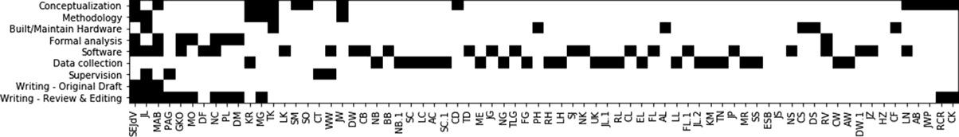

An example authorship matrix suggested by Nick Steinmetz, University of Washington

### Research Funding

Funding enables research to be conducted, the publication of manuscripts, training of students, and facilitates collaboration. Serving as the PI of IR grants demonstrates leadership in team-based research. Although research funding in itself may not be an explicit requirement for promotion or evidence of scholarship, it demonstrates evidence of sustainable scholarly activity and may highlight the interdisciplinary nature of your work. Clearly articulate your role in obtaining research funding and how you and your groups’ contributions made work possible.

For example, you can use a table to articulate the funders, project, investigators, amount of funding, and your role.

|  |  |  |  |  |  |  |
| --- | --- | --- | --- | --- | --- | --- |
| **Agency** | **Title** | **Period** | **PI** | **Role** | **Total Award** | **Posner Award** |
| NIH/NIAID | A novel REverSe Transcriptase Chain Termination (RE- STRICT) assay for near-patient, objective monitoring of long- term PrEP adherence | 2020-2025 | Drain, Posner, Multi-PI | Expertise in assay development and validation  diagnostic tests | $3500k | $1250k |
| DoE | Multidisciplinary Design of an Innovative Natural Draft, Forced Diffusion Cookstove for Woody and Herbaceous Biomass Fuels in East Africa | 2013-2017 | Posner | PI, lead development of clean cookstove for Kenya. The stove is now sold commercially. | $900k | $900k |

## Section 2: Promotion Letters

**Item C: Review of Potential Letters**

At the UW, the review process for appointment and promotion varies depending on the school, college, or even department. For example, the UW School of Nursing has three administrative letters for the APT process (1-Chair’s letter, 2-APT committee letter, 3-Dean’s letter), plus the external letters of evaluation that the department chair seeks. In addition, candidates for promotion may request and submit letters of support. The following paragraphs outline specific language or examples to highlight individual contributions to IR. The paragraphs are separated by the key stakeholders who provide letters throughout the APT process that may be required in your department, school, or college.

**Department Chair**: The Department Chair can best describe the candidate’s obligations of disciplinary and departmental activities including publications, service, and teaching, and then describe their IR contributions. Department Chairs will need to identify reviewers who understand the overall quality of the IR work, especially if there is less emphasis on the output of disciplinary research productivity. IR requires extra time to build collaborative relationships with peer faculty from other disciplines. Highlighting successful collaborations and subsequent funding or discoveries is key. Chairs can highlight the following items for external reviewers:

* Provide assessment of the candidate’s contributions to IR, including grants, publications, students mentored, engagement with the community, industry, or other groups.
* Joint appointments (faculty has appointments and obligations in two schools)
* Collaborative research and teaching are the norms for this department
* Recognition of role on IR grants. Some funding agencies only recognize one PI, but departments (Schools) can recognize dual PIs if the contributions from both are essential to conducting the research. The chair would need to highlight the dual PI role and possibly sharing of indirect costs.
* Sharing of indirect cost returns across departments or schools can be highlighted to demonstrate significant contributions of the researcher to the success of the grant (if they were not the PI)
* Highlighting time spent on activities related to IR centers or affiliations in other schools that support IR
* Highlight mentorship of faculty members from other disciplines

**APT Committees**: Department and School APT Committees are advisory to the Chair or Dean, respectively. They are comprised of faculty who review appointment and promotion portfolios based on established criteria that document metrics for promotion. APT Committees are not typically experienced in evaluating a candidate’s contribution to IR. APT Committees will need continuing education and training in IR to provide an informed review specific to a team science researcher. The APT Committee Chair can identify the potential candidate as a team science researcher from the candidate’s goal statement, the letter from the Chair, review of CV, and letters from external reviewers who are judging the promotion materials from an IR perspective. APT Committees are also responsible for updating their school/college criterion based on changes to UW Faculty Code.

**Dean**: The Dean’s letter summarizes the outcome of the APT Committee’s evaluation and vote. All highlighted bullets from the various stakeholders listed above will facilitate a positive letter of support from the Dean. The Dean will have to justify to the Provost that the faculty candidate has met the criteria. The Dean will need to emphatically state that although the candidate is an IR that they have independently contributed to the development of the science. In addition to the examples above, we’ve provided an exemplar letter in the next section from an external reviewer. This template can also be used and adapted for any of the letters referenced for the APT process.

**Item D: Letter to external reviewers (evaluation letter)**

This letter is intended for Department Chairs to send to external reviewers to evaluate a faculty candidate seeking promotion. The exemplar letter below highlights and provides sample language to demonstrate the value of specific individual contributions working within IR. If a school does not have associated metrics for documenting team science contributions described in the criteria that are shared with external reviewers, then the Department Chair will need to highlight the candidate’s team science achievements in the context of APT and policies and highlight institutional support for the value of team science at UW.

**APT TOOLKIT: DEPARTMENT CHAIR LETTER TO EXTERNAL REVIEWER**

**From:** Department Chair

**Sent:** Friday, June 28, 2019, 2:00 PM

**To:** [XXX@UX.edu](mailto:XXX@UX.edu)

**Cc:**

**Subject:** University of Washington - Promotion Evaluation Request – Dr. XXXX

Dear Dr. XXXXX,

The School of Nursing is considering Dr. XXXXX for promotion to the position of Associate Professor, Tenure Track in the Department of Biobehavioral Nursing and Health Informatics, School of Nursing at the University of Washington. Dr. XXXX has provided your name as a possible reviewer/evaluator to assist in our decision-making process. We would appreciate your candid assessment of Dr. XXXXX’s scholarly contributions. If you agree to be a reviewer we will electronically forward you their CV, samples of their published papers, and their professional goal statement. In addition, we will send for your reference the Appointment, Promotion, and Tenure Criteria for the University of Washington School of Nursing.

I know that you are busy but I sincerely hope you will consider our request. If you agree to provide an evaluation for Dr. XXXXX, we will email the materials to you by [Date]. We would need your evaluation by **[Date].** The opinions of outside reviewers are a necessary and valued part of the University of Washington's appointment process. Your letter will help us to document the external evaluation of Dr. XXXXX’s work.

Of note, Dr. XXXXX has described themselves as an interdisciplinary researcher. Dr. XXXX has been a major scientific contributor to several funded research grants, but not necessarily as the principal investigator. Interdisciplinary research is highly valued at the University of Washington and we intentionally seek reviewers with experience in interdisciplinary research. We recognize that the challenge of solving complex unmet challenges and its scholarship as an intellectual pursuit may not be limited to one discipline. In order to assist in the evaluation and assessment of an interdisciplinary scholarship and how it integrates with the candidate’s scholarly portfolio, all candidates for promotion who identify as interdisciplinary researchers are required to provide additional materials. These materials include a statement of their role in the design and conduct of funded research in their promotion packet if they served as a major scientific contributor but not as a principal investigator on a funded research grant. The candidate is also asked to briefly describe (in the goals statement) any interdisciplinary scholarship, including details of the interdisciplinary nature of the activity or project, departments of disciplines involved, their role in the activity, and the contribution of their work to the related disciplines. They are to include publication and submitted grants (funded or not) derived from these activities, and participation in interdisciplinary centers. We would appreciate your assessment of this candidate within the context of an interdisciplinary researcher.

Under University of Washington policy your letter, as part of the official personnel file, will be held in confidence. While not given access to it, the candidate and/or members of the public may be, upon formal request in accordance with the Washington State Public Records law, provided with excerpts of all such confidential evaluations in the candidate's file without disclosure of the identifications of the evaluators.

Interpretations by the courts of the Washington State Public Disclosure law have held that external letters of evaluation sought in the normal course of appointments are exempt from disclosure. The University treats these letters as internal confidential documents and does not release them to the candidate nor others outside of faculty and administrators directly involved in the appointment decision process. We commit to retaining your evaluation in such confidence, except to the extent we are required to disclose its contents by adjudication or court order, and even then, we will make every effort to protect your personal identity.

Thank you very much for your consideration and please let me know at your earliest convenience whether you can do the evaluation.

If you have any questions, please feel free to call me at 206-XXX-XXXX. Department Chair

Department of XXXXXXXX

University of Washington Seattle, WA 98195

## Section 3: Institutional Structures & Policies

**Item E: UW Office of Research Resources**

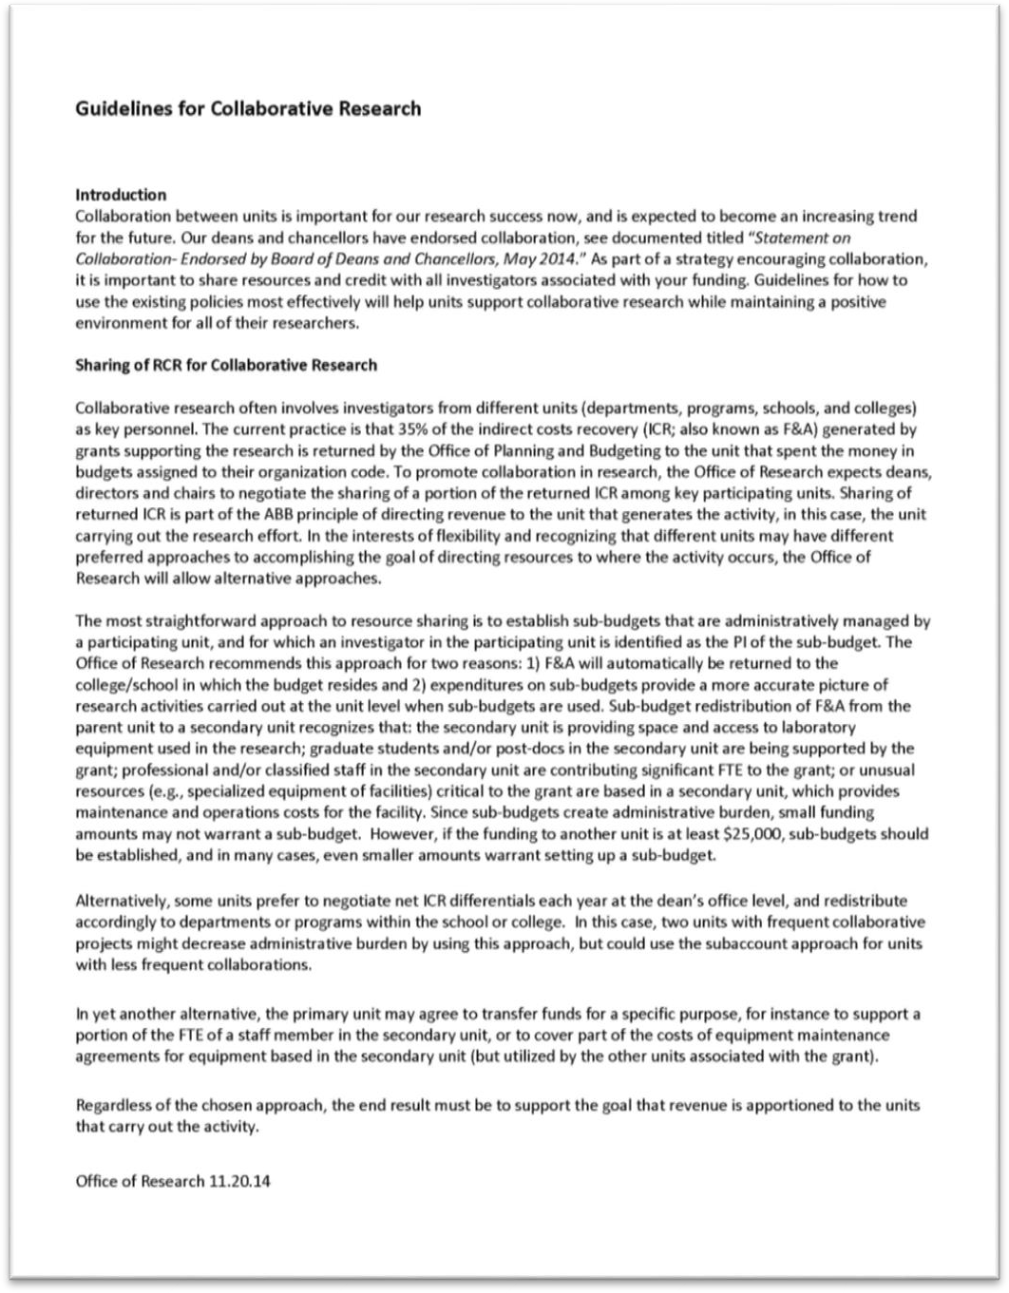Resources from the UW Office of Research include 1) Guidelines for Collaborative Research Sharing, and 2) Best Practices for Coordination and Set-up of Cost Sharing for Collaborative Proposals. Links to multiple collaborative resources including funding opportunities, web resources, and more can be found on their website at <https://www.washington.edu/research/collaboration/interdisciplinary-resources/>.

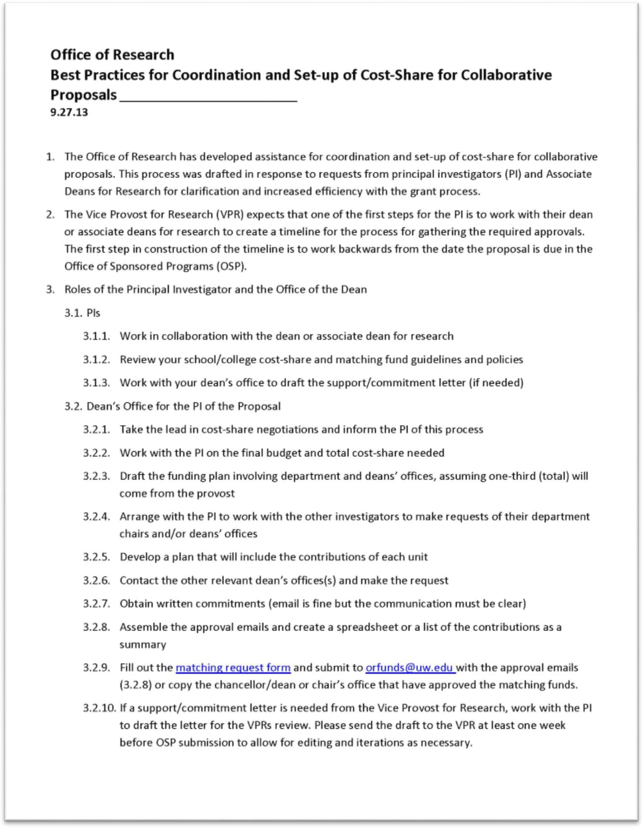

**Item F: Scholarly Identity and Digital Portfolios**

In our current academic environment, it is vital to create and maintain your scholarly identity and digital portfolio. The following resources are available to help faculty maintain an Author Profile to make their research and interests visible to a larger audience. These resources assist in measuring research impact and can also be used in promotion folders and packets.

[ORCID](https://orcid.org/)

This free resource creates a permanent 16-digit identifier that can be used to track your scholarly contributions throughout your career. It is being adopted by some granting institutions and publishers. ORCID can be linked to a brief biographical statement, education, grants, and scholarly works.

[Google Scholar](https://scholar.google.com/)

Google Scholar is a rapid and simple database for tracking publications, including conference contributions and patent applications. Each investigator has their own account and Google Scholar that will list scholarly contributions as well as provide links to full text, track citations, and impact metrics (e.g., h-index). The service will automatically gather scholarly contributions and request confirmation that appear to be authored by the account holder. Citation counts on Google Scholar have a risk of being inflated due to duplication by the Google algorithms.

[Web of Science](https://alliance-primo.hosted.exlibrisgroup.com/permalink/f/kjtuig/CP71114752760001451) (subscription database through UW Library)

Web of Science is a subscription database that can be used to obtain citation counts. Note that Web of Science only tracks citations to a limited set of journals.

[Semantic Scholar](https://www.semanticscholar.org/)

Semantic Scholar is a STEM database that provides citation counts and provides information on *Influential Publications* that may have cited your work. It will also inform you if you were cited in the Background, Methods, or Results sections of the citing paper.

[Dimensions](https://www.dimensions.ai/)

Is another free database that enables sorting publications by citation count or by Altmetric score. Altmetrics is a measure of mentions on social media and non-scholarly sources, including the CDC, WHO, New York Times, Huffington Post, or other tracked news sources. This may be an effective measure of cross-disciplinary impact. This database can pull data from ORCID (among other sources).

For more information or questions, please contact Lynly Beard ([lynly@uw.edu](mailto:lynly@uw.edu)), *Research Impact and Social Work Librarian,* with the UW Health Sciences Library.

# Acknowledgments

gold boundless bar

**Funding:** This toolkit was supported by the National Center for Advancing Translational Sciences of the National Institutes of Health under Award Number UL1 TR002319. The content is solely the responsibility of the authors and does not necessarily represent the official views of the National Institutes of Health. We thank Frances Chu and members of the APT Committees in the Schools of Health Sciences and College of Engineering for their contributions and feedback on this toolkit.

**Content Contributors:** Lynly Beard, MLIS, Sara Kover, Ph.D.

# References

gold boundless bar

Institution of Medicine 2005. Facilitating Interdisciplinary Research. Washington, DC. The National Academies Press. <http://doi.org/10.17226/11153>

National Research Council. 2015. Enhancing the Effectiveness of Team Science. Washington, DC: The National Academies Press. <https://doi.org/10.17226/19007>.